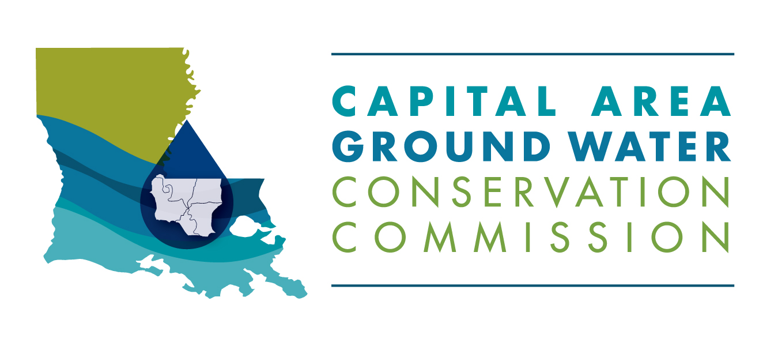
PUBLIC HEARING
DOCKET NO. CAGWCD 2019-01
Proposed Budget FY 2020

8:30 AM
June 12, 2019

Hearing Officer

Anthony J. Duplechin, Jr., PG.
Executive Director, Capital Area Groundwater Conservation District

Agenda

- Welcome
- Filing of State Exhibits
- Public Comment
- Adjournment

